Internal Mechanism:

<https://www.youtube.com/watch?v=8HyCNIVRbSU>

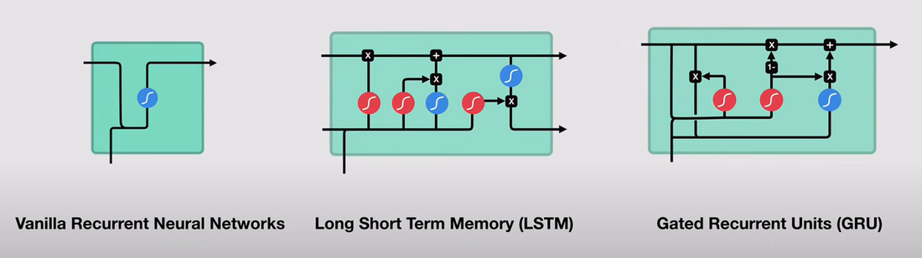

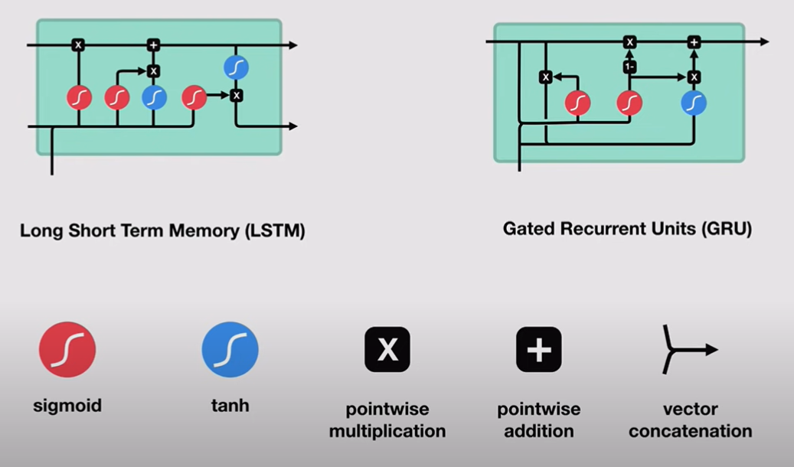

LSTM and GRU has gates that regulate the flow of memory

